Meeting Report: 9/4/2024

Action Item 1: Recruitment

* Gabi has been contacted and is actively recruiting.
* I have posted the flyer in multiple locations on campus

Good. As you know, Gabi is only part-time and although she can assist with things like recruiting, you should expect to conduct testing yourself. She has other tasks assigned to her.

Yes, she is just helping with recruitment. I will update as things move along. I believe several calls have gone out to local universities and other organizations.

Action Item 2: Meeting is Nvidia

* Only one participant has been done for look this week
* **What is the participant number that is we need before talking to Nvidia?**

The group is interested in both innovative methods for analyzing gaze but also the results of this unique study.

For participants, at least 30 (15 in each group) would be needed for a preliminary presentation for folks to pay real attention to the results. 20 participants in each group would be the target number at which we can pause and consider the data for different publication venues. Note that this is kind of low for a lot of comparable research. The better answer to this question would be determined by a power analysis calculation. For better or worse, what we are trying to do here is really new and we don’t have good prior data on which to base the power analysis.

Makes sense to me. A power analysis would be difficult here for the CGP given that this is not usually a comparable task to measure across groups. Might not be able to determine a viable difference effect. However, I will think about it. Quiet eye might be possible due to it being that we are making a more standard comparison for that effect however, this is far from the traditional QE task so I will also look at some other past results.

Regarding the methods, we would want to show CGP and also some quiet eye results. This would make for a meaty 45 minute presentation. Giving yourself ample time for data collection, making sense of the data and crafting compelling visualizations, when do you think you could feasibly give that talk?

Probably could have something by the end of the month which includes the methods and research visuals, but I have no way to gauge when we get the participants. That will most likely happen in waves.

Action Item 3: Aggregate data and show figures from last paper.

It is good to see this all together. Would also be nice to see a side-by-side comparison with the prior experiment so we can really compare how exactly things differ.

Also, how many more non-autistic participants do you need for a full matched sample here? And that number is 20 in each group or 25?

Replication of past results with a near-similar task is comforting. So, this is a bit unsettling, of course. A side-by-side comparison would help guide our thinking, and of course we want to have the full complement of data to consider. If I am remembering correctly, when we last spoke, we were still seeking 4 or 5 non-autistic participants for Loom, which could change numbers a good bit given their proportion of the overall sample.

Even though you know it is low, it is worth also calculating looking time at the other playing partner in dyadic conditions. It is also worth looking at transfer time between different segments in different conditions.

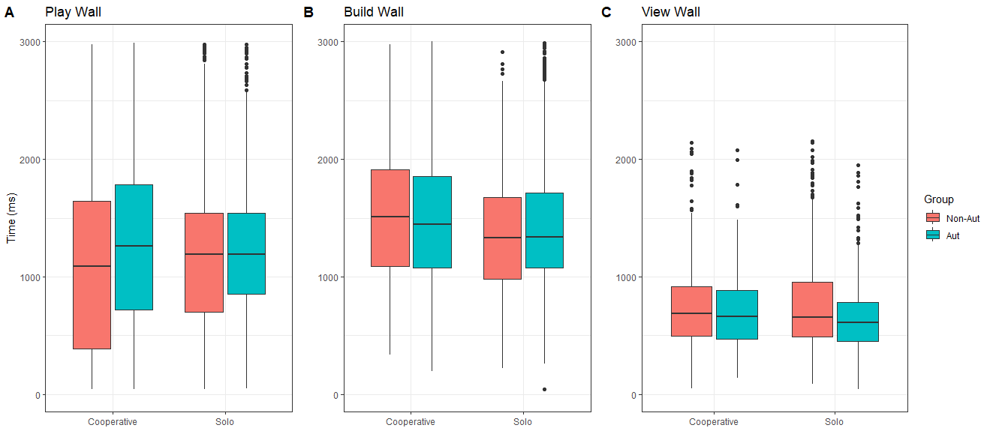

**Gaze Data**

These results are very similar to the last experiment.

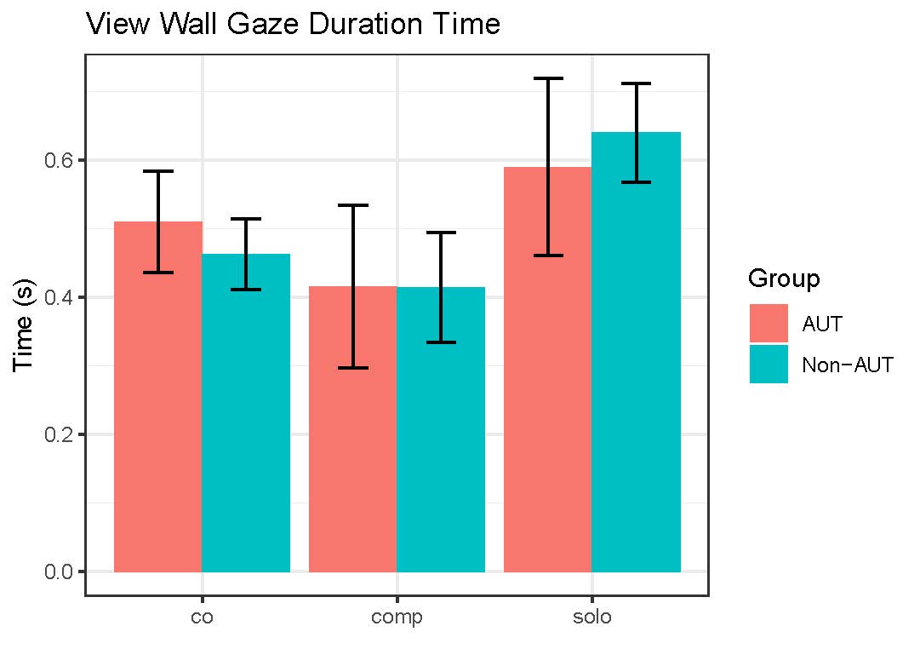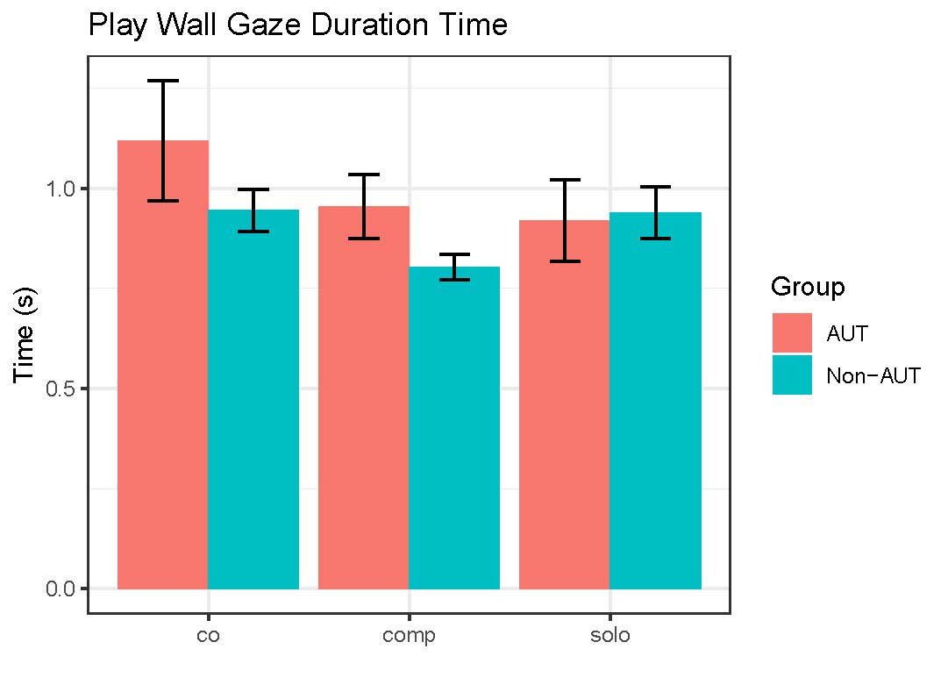

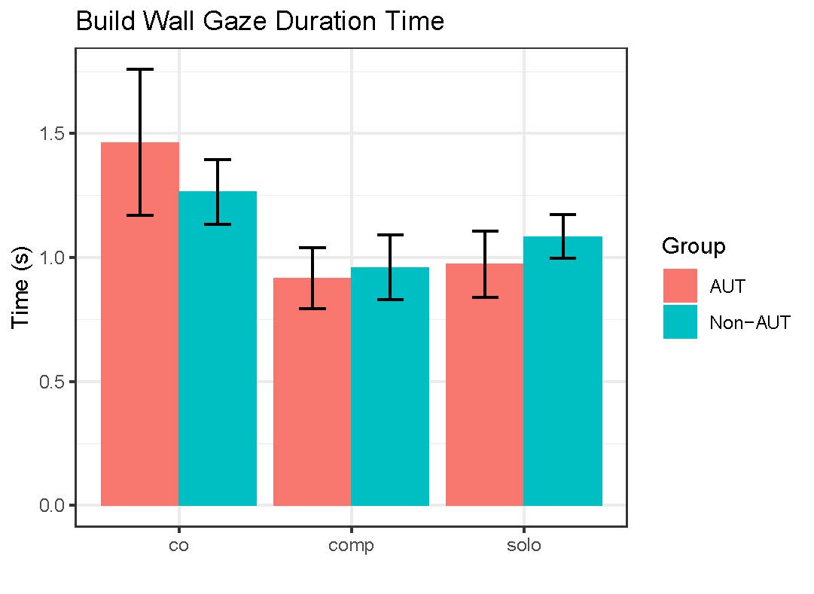

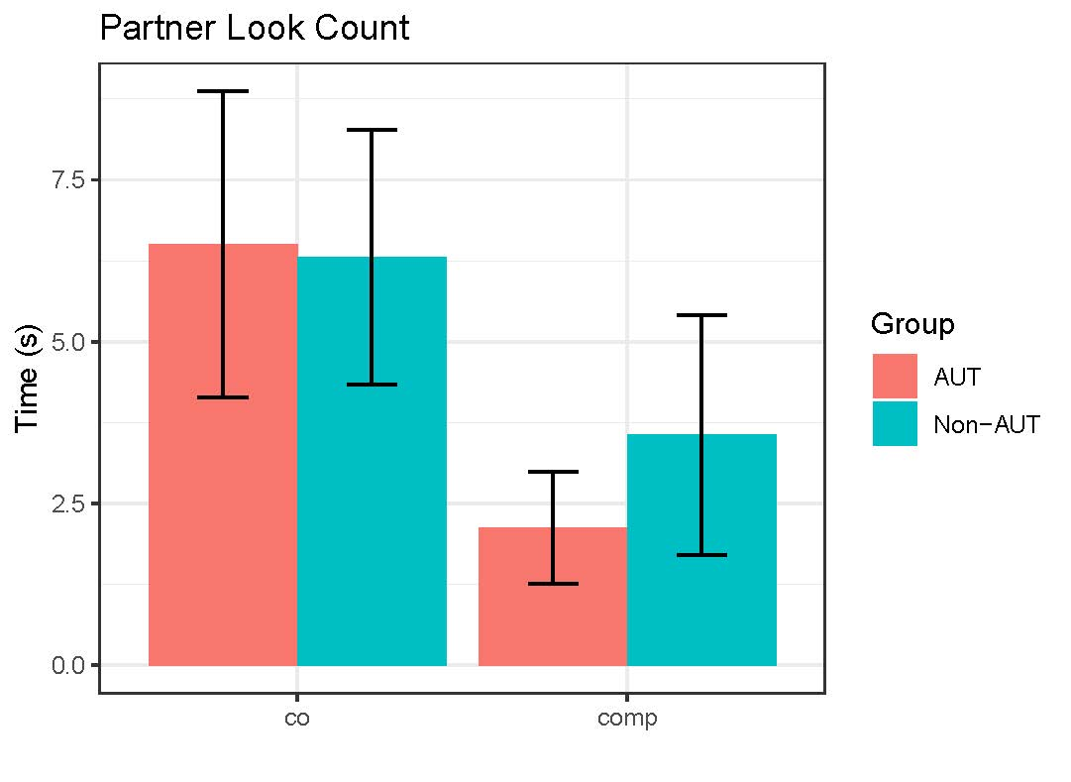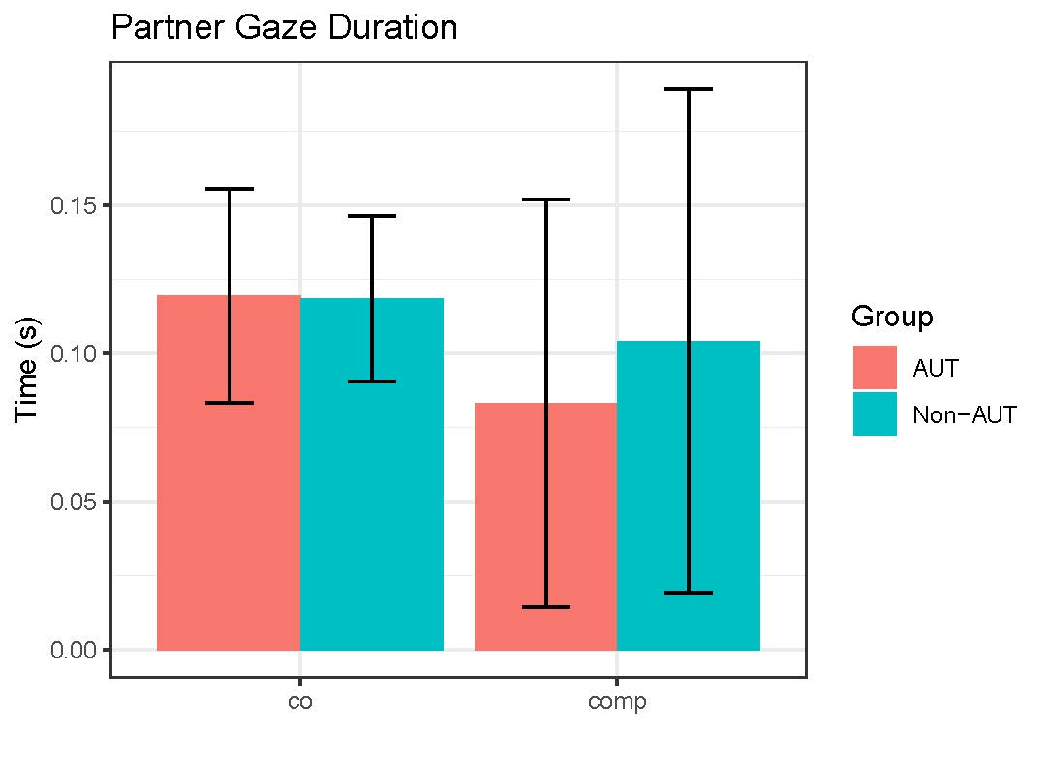

**Movement Data**

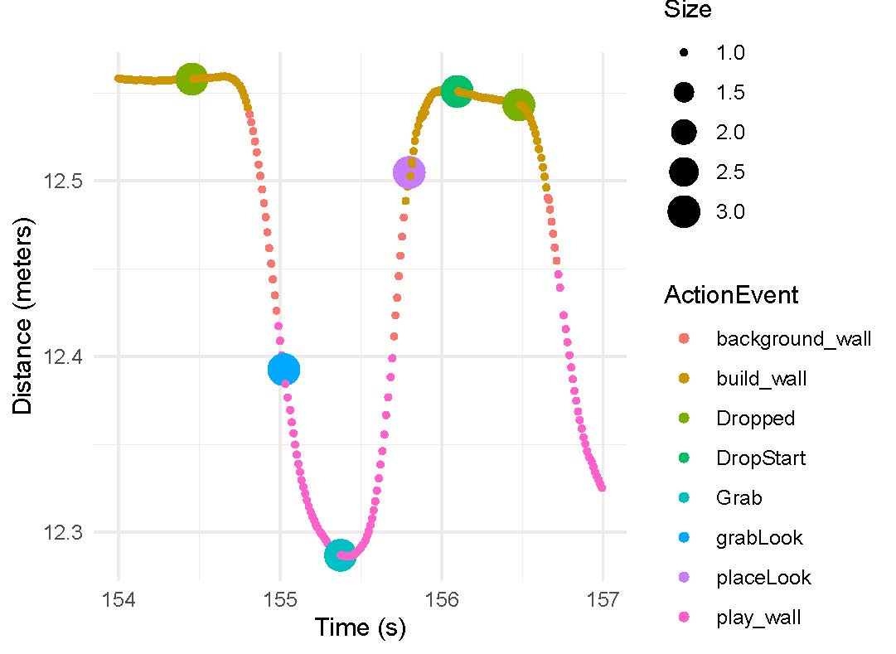

**X-Axis Hand Movement**

Drop / Place

Grab

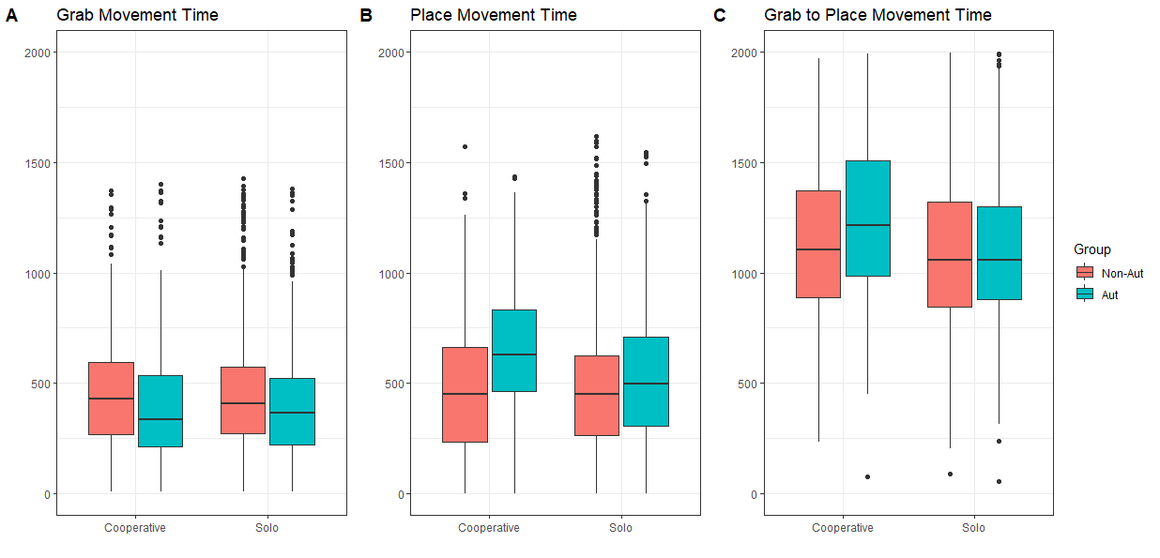

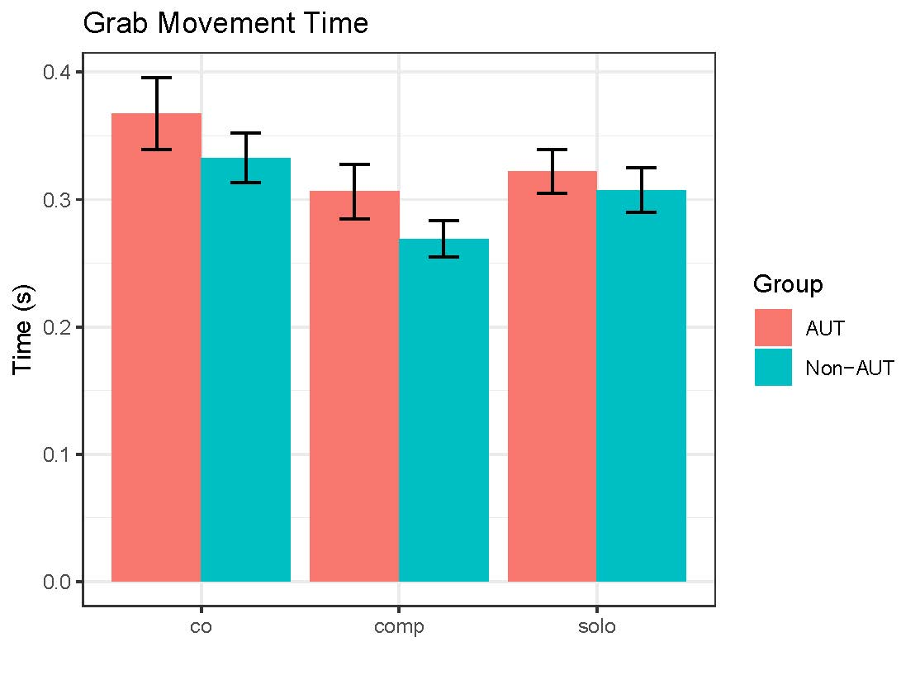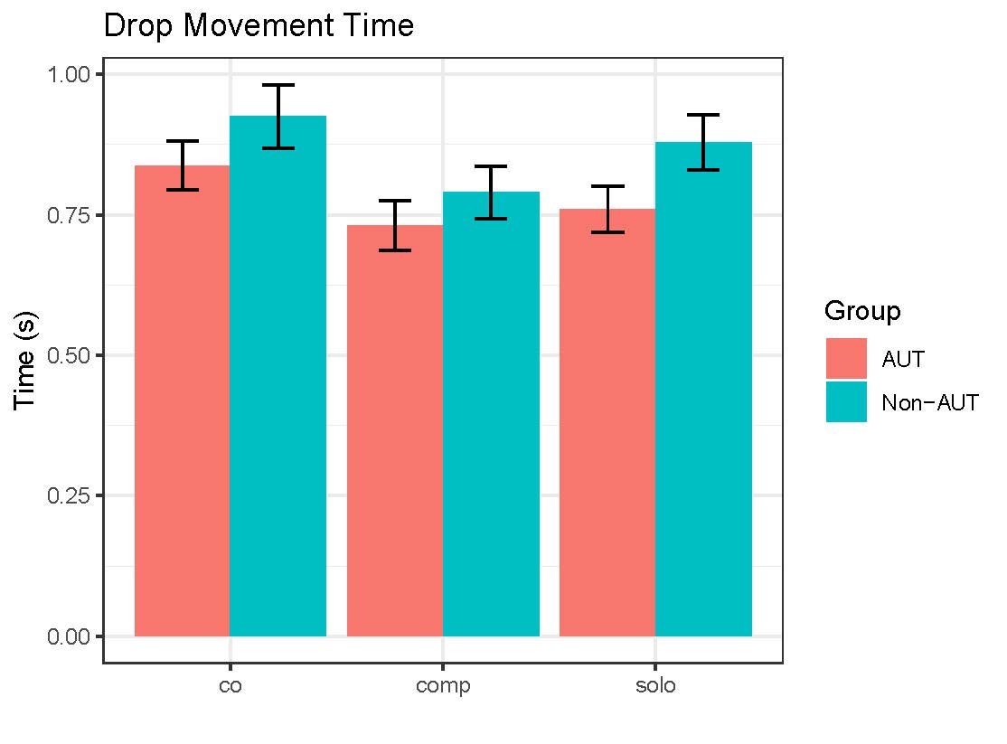

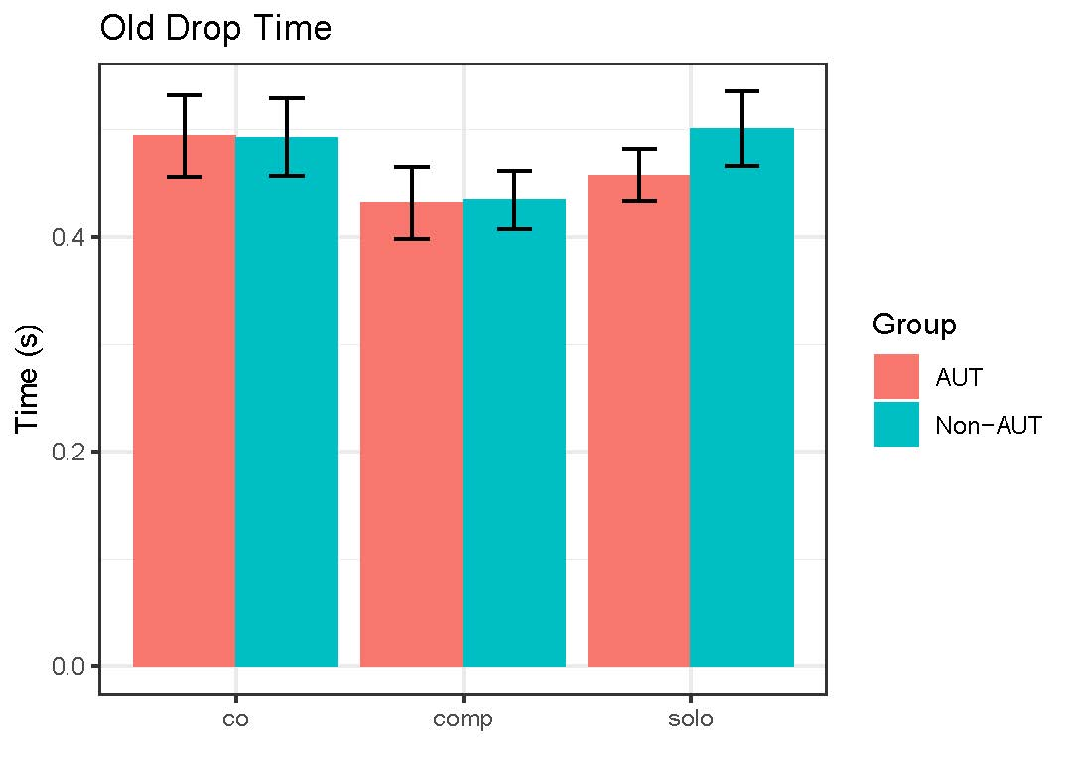

* **Grab** has changed a bit in the way that we had intentioned. We see a slight trend with the AUT group taking longer to perform this movement than Non-AUT in the social conditions.
  + This might be due to the increased and diversified movement speed of the cubes.
* **Drop** has also changed from the previous experiment. With this data showing the Non-AUT group taking longer to perform this movement.
  + This could be due to a slight change in the measure from the previous task. (shown below)

**X-Axis Hand Movement**

Previous

Current

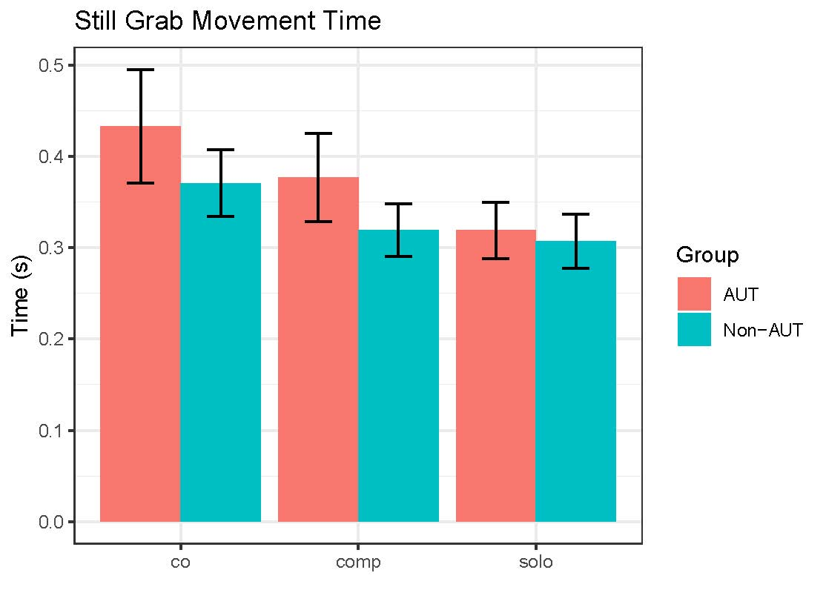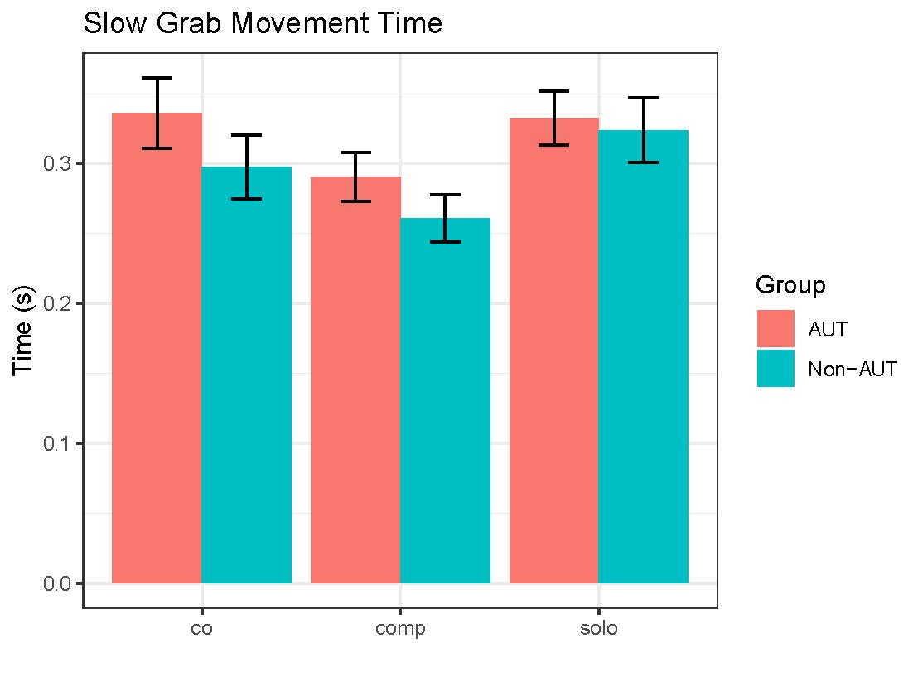**Cube Speed Measures:**

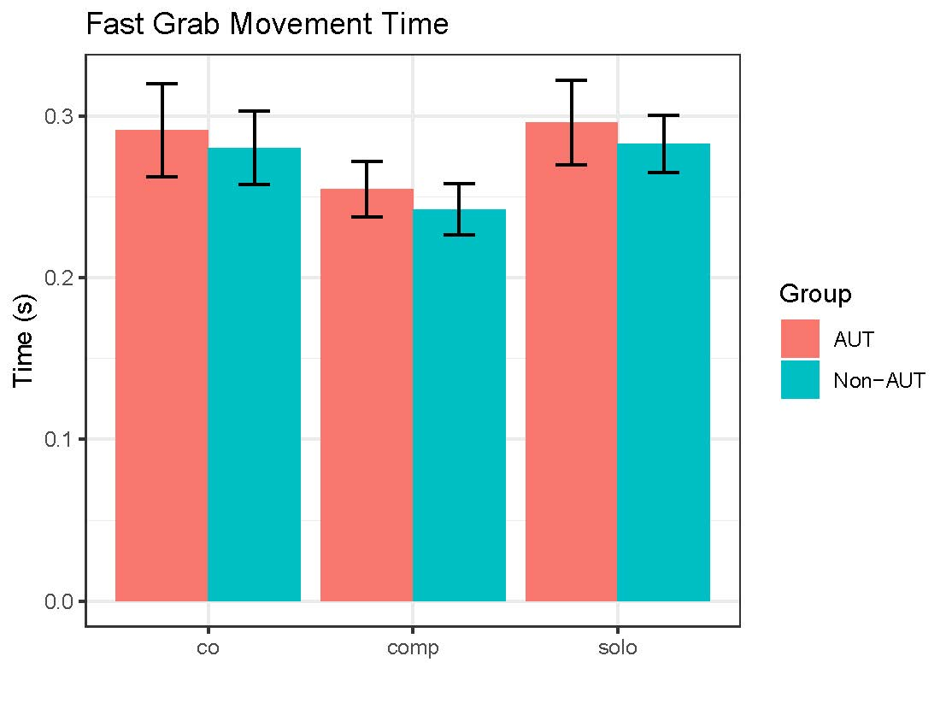

One other interesting thing to compare across speeds is to look at relative speed change for each group—that is how much are the autistic and non-autistic players changing their movement speed relative to environment speed in each conditio0n. I find it interesting that in the solo condition—the movement to slow and fast block motion are slower than the comparable coop and comp conditions.

Looked at it another way, movement to the blocks in the solo condition is pretty consistent across block motion speeds (still, slow fast). In the still condition, the speeds to coop and comp increase a bit relative to solo, whereas those conditions are the same or faster for slow and fast block speeds. This is interesting, potential emerging differences across group notwithstanding.

**Discussion of Potential Next Steps:**

1. Any Suggestion?
   1. See notes above about needing last participants to be sure of what we’ve got. Let’s also try to compare apples and apples between task variations**. Finally, if you want to sit down and look through the code for possible ways this could be calculated differently between task variants, we can do that. As you know, when you are the only one conducting an analysis with a task that you also built, it is easy to overlook potential errors. Walking someone else through the analysis can help. We’ve done this before and it might be good to do again.**
      1. This is something that I want to do 100%
2. Drop analysis based on the previous task’s parameters.
   1. Yes. We should look at this both ways.
3. Arousal Measures.
   1. Can you make the same measure you did previously? What does that look like compared to the last study’s similar analysis.
      1. Yes we can get the same measures.
4. Analysis of kinematic measures for Gaze, Hand & Head (maybe) for Grab and Drop including:
   1. Velocity
   2. Acceleration
   3. Jerk
5. Inserting the head rotation data into this figure:
   1. **QUESTION: We need a decision about where to insert Start and Stop parameters for Head Rotation?**
   2. In the figures below from (Pelz, 2001) A similar task is able to classify head rotation into “Pick Up” and “Drop” groups. However, They did not use the head data to make this classification which we could potentially do.

I think it is best to actually use head rotation data since we have it. Triangulation of methods is valuable for the field, though. My suggestion is that you calculate head rotation multiple ways and compare. Definitely look at what Pelz does (I see you are plotting in quaternions! Seriously weird space but relevant for gaze and gaze-in-head. Not strictly necessary though unless we want to argue something strongly about 3D eye movements and especially transitions between those. That is when this kind of math is useful. Most of the world prefers not to think in quaternion algebra.

I will probably change it to degrees since that looks to be more normal but since the raw data is in quaternions I need to do a bit more work on the conversion.

If you want to learn more about quaternions for your research use, I’d dig back into the literature in the 90’s especially studies by Tweed and Villus [I think… it has been a while]). Jeff Pelz’s work is really relevant here as is Mary Hayhoe’s. They have a nice [2012 EBR article](https://link.springer.com/article/10.1007/s00221-011-2979-2) looking at natural gaze behavior during squash that I looked at in prep for the R01 earlier this summer (we proposed VR squash as a final dyadic experiment).

The eye-head and eye-hand coordination work might be nice to present at the next ETRA. Pelz used to attend these regularly as part of the old guard, but I didn’t see him in Glasgow this year.

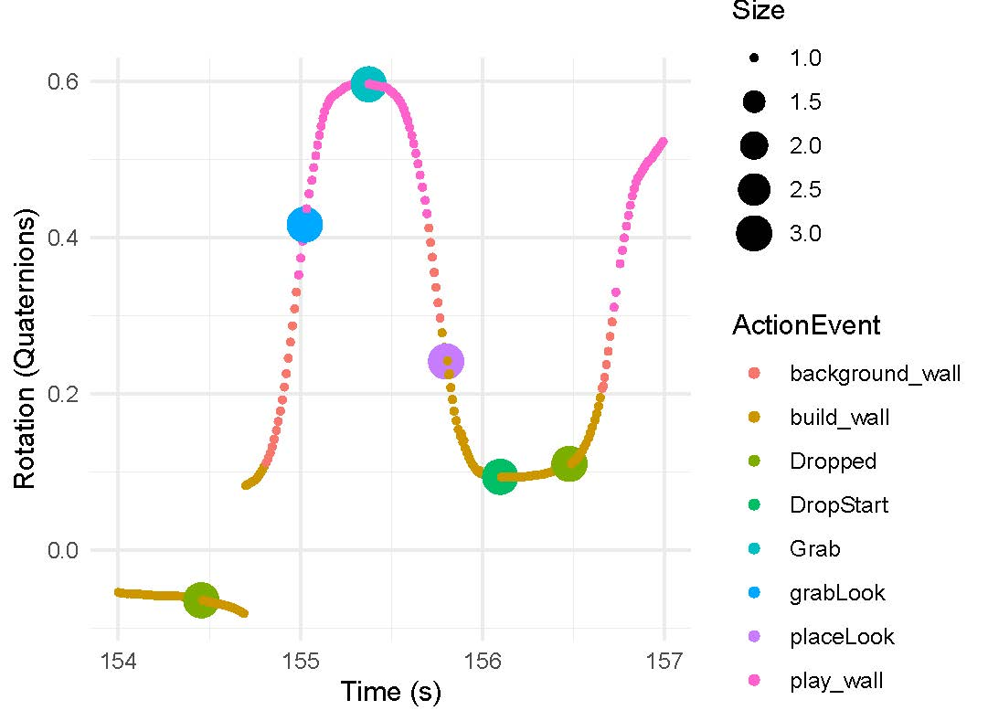

Drop Start

Drop End

Grab End

Grab Start

**Y-Axis Head Rotation**

**X-Axis Hand Movement**

Possible Head Rotation Points

**Pelz 2001**

